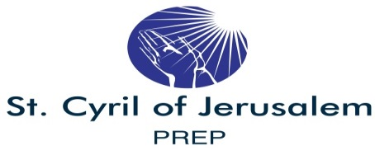
2019-2020 Calendar Level 7
Confirmation Preparation Program

SEPTEMBER
22-SM Classes - Opening Class
24-SM Classes- Opening Class

OCTOBER
13-SM Classes
15-TE Classes
27-SM Classes
29-TE Classes
NOVEMBER
10-SM Classes
12-TE Classes
24-26 - No Classes - Thanksgiving Break
DECEMBER
1-SM Classes
3-TE Classes
15-SM Classes/Advent Confessions
17-TE Classes/Advent Confessions
22-24 & 29-31-No Classes Christmas Break

Program Information:

- Sunday Morning Classes (SM) - meet 10:00am-11:30am
- Tuesday Evening Classes (TE)- meet 6:30pm-8:00pm
- Classes
- Since classes meet only 10 times during the year, it will require consistent attendance, limited tardiness/leaving early, completion of home assignments/reading, service projects, etc.
- A Sacrament Preparation Assessment will be
conducted in March to ascertain candidates readiness for the reception of the Sacrament of Confirmation

JANUARY
5-SM Classes
7-TE Classes
26-SM Classes
28-TE Classes

FEBRUARY
2-SM Classes
4-TE Classes
11-Candidate/Parent Confirmation Retreat - 6:30pm
Social Hall
23-SM Classes
25-TE Classes

MARCH
1-SM-Classes -Preparation Assessment/Practice
3-TE Classes -Preparation Assessment/Practice
10- Combined SM & TE Classes - 6:30pm - 8:00pm for
Mandatory Confirmation Practice in Church
18-Candidate/Sponsor Practice - 7:00 p.m. Church
19- Sacrament of Confirmation - 4:00 p.m.

Session Time Locations
SM- Sunday Morning 10:00am-11:30am Rectory or Portables (P)
TE - Tuesday Evening 6:30pm-8:00pm " "

8/26/19

